Question 1: Dijkstra’s algorithm may not terminate if the graph contains negative-weight edges. True/False Justify your answer.

|  |
| --- |
|  |
|  |
|  |
|  |
|  |

Question 2: Consider a weighted directed graph G = (V, E, w) and let X be a shortest from s to t for s, t ∈ V . If we double the weight of every edge in the graph, setting w’(e) = 2w(e) for each e ∈ E, then X will still be a shortest s-t path in (V, E, w’ ). True/False Justify your Answer.

|  |
| --- |
|  |
|  |
|  |
|  |
|  |

Question 3: A root of a directed graph G=(V ,E) is a node r such that every other node v is reachable from r. Give an example of a graph which does not have a root.

|  |
| --- |
|  |
|  |
|  |
|  |
|  |

Question 4: Given pseudo code of Dijkstra’s Algorithm.

*//Initialise single source(G,s)*

S=0

Q=V[G]

While size(Q)!= 0

Do u=extract-min(Q)

S=S union {u}

For each vertex v in adj[u]

Do relax(u,v,w)

What happens when “While size(Q) != 0” is changed to “while size(Q)>1”?

|  |
| --- |
|  |
|  |
|  |
|  |
|  |

Question 5: Consider the following graph.

[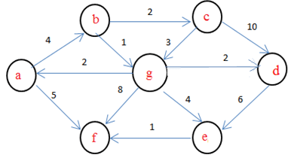](https://www.sanfoundry.com/wp-content/uploads/2018/07/dijkstras-algorithm-questions-answers-q13.png)  
If b is the source vertex, Find the cost to reach f vertex? Show the working of the queue and the path from b to f.

Question 6: Construct a min-heap from the Array given below.

|  |  |  |  |  |  |  |  |
| --- | --- | --- | --- | --- | --- | --- | --- |
| 2 | 3 | 6 | 8 | 9 | 10 | 12 | 18 |

Show the steps and the resulting heap after a single Extract-min Operation.